Number the following muscle structures in order from largest to smallest:

______myofibril ______myofilament ______sarcomere ______fascicle

______muscle ______muscle fiber

Please label the diagram below. I know this is on the EOPA.

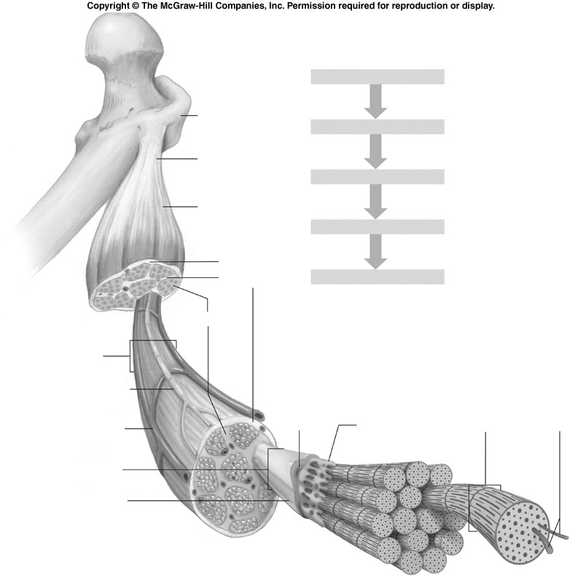

5. What is the difference between actin and myosin?

6. What produces striations in muscle fibers?

7. Draw and label a sarcomere below. Include the following labels:

I band A band H zone myosin
actin sarcomere Z line

8. What is the name of the site on a muscle fiber where a motor neuron connects?

9. Name the neurotransmitter that stimulates muscle contraction:

10. Physiologically, what causes a muscle contraction to stop?

11. What is the role of calcium in muscle contraction?

12. Explain the sliding filament theory.

13. What causes muscle fatigue?

