Health Care Systems Notes
Health care has become a ____________________ business!!!!!
Private Health Care Facilities
Hospitals: an institution that provides ________________________________ and treatment for the sick and injured.
Can be _______________, religious, nonprofit or ___________________ owned.
Ex.
Long-term care Facilities: mainly provide assistance and care for the ___________. Usually all in one.
_________________________: provides help with ADL’s, promote social interactions and provide safety and security.
Extended care facilities: ______________________________________________________
Independent Living: Rent apartments but are provided with services

Omnibus Budget Reconciliation Act (OBRA)
Regulations regarding _______________ care and ________________ care.
- Requires state to establish training and competence evaluations for nursing and geriatric assistants.
- CEU’s, evaluations, registrations and certifications
Medical Offices: _____________________________________________
______________________________________________________________
Services: diagnostic, evaluations, treatment, examinations, minor surgeries, and testing
Dental Offices: can provide general or specialized care
Ex.
Clinics: health care facilities found in many types of health care.
Optical Centers: ______________________________________
_________________________________: provides special care for victims of accidents or sudden illnesses
Can be both _________________ or _______________
Laboratories: can perform __________________________ such as blood or urine

Government Agencies
World Health Organization( ): information about health issues around the world
(U.S.D.H.H.S.) ______________________________: health issues in the U.S.
National Institute of Health(NIH): _________________________
Center for Disease Control and Prevention( ): concerned with causes, spread and control of diseases
Food and Drug Administration( FDA):________________________
Agency for Health Care Policy and Research( ): ____________
Occupational Safety and Health Administration( ): protect workers from ____ ________injuries and illnesses
Voluntary/Nonprofit Agencies
Supported by ________, membership fees, ____________ and federal or state grants.
EX:

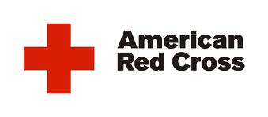
Health Insurance Plans

What's the Purpose?
- _________________________________________________________
How does it work?
- The amount of payment and the type of services vary from plan to plan
  - ______________: set amounts that must be paid before the insurance will pay for anything.
  - Co-Insurance:___________________________________________________________
  - ________________: specific amount of money that must be paid before receiving services
Health Maintenance Organization (HMO): provides a _____________________________________ for the delivery of healthcare services
  - Set fee regardless of the amount of health care used
Preferred Provider Organization(PPO): contracts with certain doctors/dentist to provide health care at reduced rates
  - Usually requires ____________ and _________________
  - Medicare: government program that provides healthcare for all individuals over the age of ______, disabled persons receiving SS and a few other exceptions
________________: Government program but people covered varies from state to state.
  - Individuals with low income, children who qualify, all disabled and blind people.
____________________________: insurance for workers injured on the job
TRICARE: Government_________________ health insurance

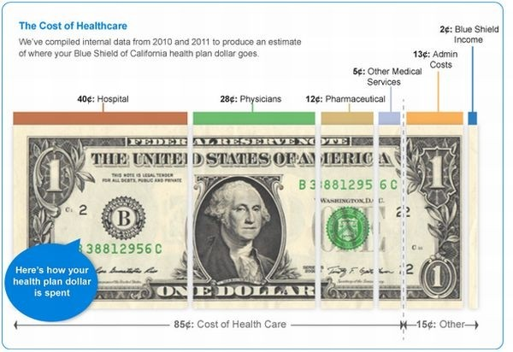

Organizational Structure

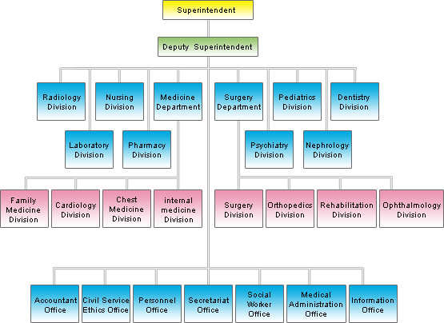

Current Trends in Health Care

Cost Containment
Cause of Increased Healthcare Costs
Technological Advances
- Procedures such as heart, lung, liver or kidney transplants
- Computers used for diagnostic exams
- People are living longer buuuuttt…….the result is …
The Aging Population
- More ________________________
- _______________ diseases
- More frequent healthcare
Health Related Lawsuits
Cost Containment Efforts

Diagnostic Related Groups
  - Medicaid/Medicare:
    - _________________________________________
    - _________________________________________
Combination of Services:
  - Clinics and laboratories _____________________ by different agencies
  - Decreased cost for the provider means decreased cost for the patient.
Outpatient Services
- Reducing the length of __________________________________________… i.e. open heart surgery
Mass/Bulk purchasing
  - Buying in larger quantities at reduced prices.
  - ___________________________________________________________
Early Intervention/Prevention
  - Patient education, immunizations, physicals, incentives, easy access
Telemedicine:___________________________________________________________________________________________________________________________________________________________________
- Decreases the need for trips to the “doctor”
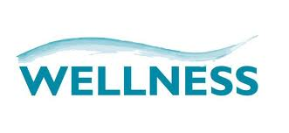
Emphasis on promoting wellness of the _______________individual:
  - ________________ wellness: promoted by a well-balanced diet, exercise, routine physicals.
  - Emotional wellness: promoted by an understanding of one’s own ________________ ______________
  - ________________wellness: promoted by showing fairness, concern, tolerance, etc…
  - Mental and intellectual wellness: promoted by being creative, logical, curious, open minded individuals
  - Spiritual Wellness: promoted by using______________________________________________________
  - Holistic Health: promotes treating the whole person; ______________________________ of wellness

Alternative and Complementary Methods of Health Care

Complementary Therapies: used in __________________ with conventional medical therapies
___________________ Therapies: used in place of biomedical therapies
Integrative health care: uses ______________ mainstream and CAM therapies to treat patients

- Chinese medicine practitioners: holistic based healing practice based on the belief that a _________________________ (CHI) flows through every living person
- Chiropractors: practice base on the belief that the brain sends vital energy to all body parts through nerves is the spinal cord
- Homeopaths: belief in the body’s abilities to ___________________________ using the immune system; no medicine, if so all natural
- Naturopaths: only natural therapies

