Range of Motion, Flexibility & Strength
Range of motion is the term that is used to describe the amount of movement you have at each joint.
  - PROM:____________________________________________________

  - AROM:____________________________________________________

  - AAROM:____________________________________________________
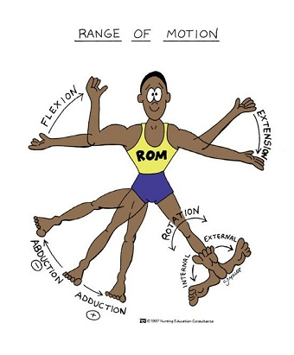
  - RROM:____________________________________________________
Guidelines for ROM:

Gonimetry:___________________________________________________________________________
- Stationary arm : ___________________________________________________________
- Movable arm : ____________________________________________________________
- Axis of rotation(pin) : ______________________________________________________
PROCEDURES:
- position joint _________________________________ and stabilize proximal joint component
- move joint to end of range of motion. Why?
- determine __________________________________________ at point where measurement will be taken
- identify and palpate bony landmarks
- align goniometer with bony landmarks while holding joint at end of range
- read the goniometer
- record measurement
Flexibility:___________________________________________________________________________
- Flexibility is influenced by:
  - ____________________________________________________________
  - ____________________________________________________________
  - ____________________________________________________________

Why is Flexibility Important?

Science of Stretching

STRETCH REFLEX:
  - Muscles contract in response to _________________________________________

__________________________________________ (GTO):
  - Located in tendons and is increasingly activated with ____________________________
  - Inhibits muscle activation in an effort to _______________________________________
Reciprocal Inhibition: ___________________________________________________________________
Autogenic inhibition: ___________________________________________________________________

Stretch Reflex and the effects of the GTO must be overcome to achieve muscle adaptations during flexibility training. What is the best way to make this happen?

General Flexibility Guidelines

Form can be altered with decreased ROM, reducing biomechanical efficiency and creating a climate for athletic injuries.

Benefits of flexibility
  - _____________________________________________
  - _____________________________________________
  - _____________________________________________

Flexibility Methods
Static Stretching
  - Stretching to a comfortable position and holding for a period of time.
  - Hold stretch for ____________________________________ (longer time, less intensity)
  - Should be used at ___________________________ of a training session
Ballistic stretching
  - Use of __________________________________ to bounce at the end range of a stretch
Dynamic stretching
  - Active muscular effort are used to propel the muscle into an extended range of motion
  - ________________________________________________________________________
  - Beneficial way to warm up ____________________________________

Benefits
    - ______________________________________________________
    - ______________________________________________________
    - ______________________________________________________
    - ______________________________________________________

_________________________________________________________ (PNF)
  - Muscles to be stretched is first contracted_________________________
  - The muscle is then relaxed and is either actively stretched by contraction of the opposing muscle or is passively stretched
  - _____________ types
    - Contract/Relax

    - Hold/Relax

    - Slow Reversal Hold Relax

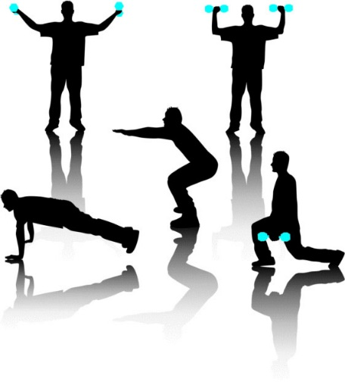

Prehabilitation, Rehabilitation and Restoration
Prehabilitation:
  - Trying to prevent injuries before they occur through a preventative management program
  - Strengthening ____________________before a Sx to decrease deficits.

Restorative Care
  - Helping attain and maintain the highest possible level of __________________________
  - Focusing on mental, emotional and social well-being

Rehabilitation:
  - Programmed exercise program designed to return an athlete to fitness and competition
  - Helping patients attain the highest possible level of functional ability
  - Focusing on physical ability

Successful rehabilitation and restorative care must focus on_________________________________________________________________________________________________________________________________________________________

Principles of rehabilitation and restorative care:

Strength Training:__________________________________________________

    - Stress should be sufficient to stimulate ______________________________, but not so severe that breakdown and injury occur
Hypertrophies
Atrophies
Overload
Specificity
Reversibility
Isometric exercise
  - Muscles contract, but ____________________________________ in the affected joints
  - Usually performed against an immovable surface or object

Dynamic exercise
Movement of the joint during muscle contraction
Isokinetic exercise
  - ________________________________________________________________________
    - Combines isometrics and weight training
Circuit training
  - Six to ten strength exercises completed as a circuit
  - Improves ______________________________________________________________

